Civic Leader Sara Fenske Bahat on Why Shared Spaces Beat Debates
Meta Description: Sara Fenske Bahat explores how shared spaces like concerts and DMV lines foster surprising human connection, offering insights on unity, joy, and civic belonging.

Feature Image: Sara Fenske Bahat Concerts/DMV.png
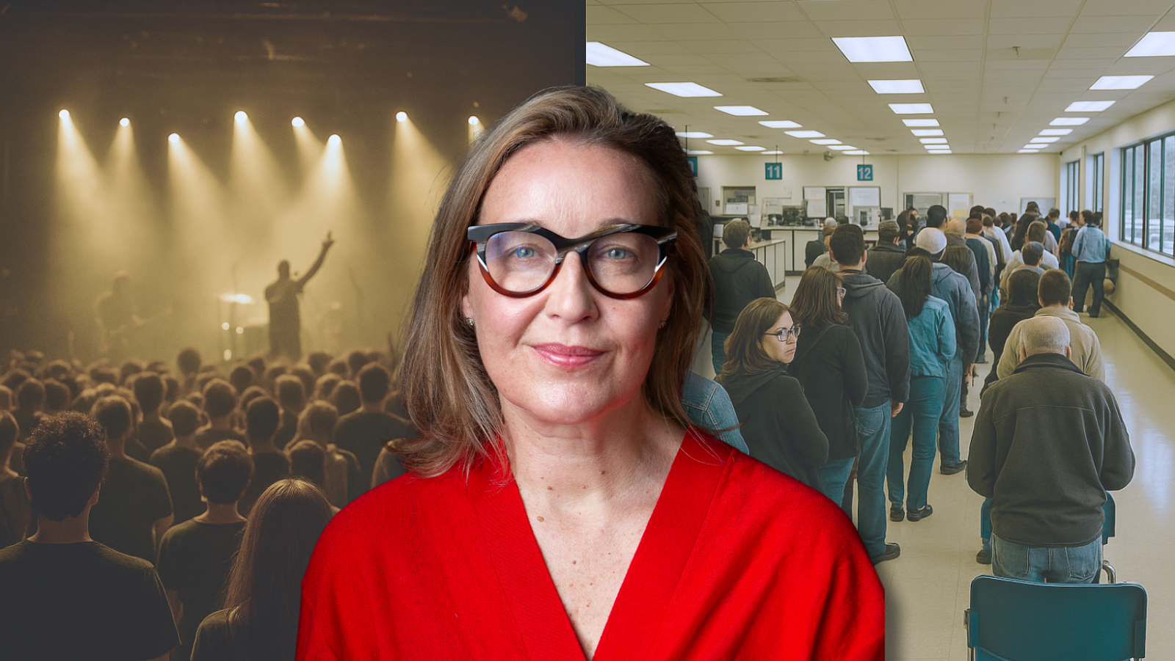
Ever found yourself at a Garth Brooks concert standing next to someone who, on paper, seems your polar opposite, yet there you both are, belting out the same lyrics with equal enthusiasm? Or perhaps you've noticed the democratic equality of the DMV waiting room, where CEOs and college students alike must take the same number and wait their turn?
Sara Fenske Bahat highlighted these everyday experiences as opportunities for connection during a recent interview about her work in civic engagement. Bahat, whose professional journey spans finance, education, and arts leadership, noted how these shared experiences reveal common ground in unexpected places.
"Everywhere we go, we get to decide how we show up. A simple change in perspective can shift going through the motions into something much more interesting." Bahat observed in her interview. "It might make us look, it might help us see one another and ourselves differently."
Her comment shows how these spaces, both celebratory and mundane, create connections across social divides. It happens without any special effort beyond simply showing up.

When Strangers Sing Together, Something Extraordinary Happens
During her interview, Sara Fenske Bahat described taking her father to see Garth Brooks in Las Vegas, a family outing that revealed something about shared experience. She recalled the diverse crowd with surprise and delight.
"We are surrounded by all these people who would never otherwise be together, period. End of story," she recalled. "From teenagers to 80-year-olds, people who look like me to Las Vegas all the way there and everything in between, including tons of rodeo wear."
What happened next surprised her. "We all sat in this room singing at the top of our lungs, embarrassing one another, embarrassing ourselves, having a good old time."
Social scientists call this phenomenon "collective effervescence," that feeling when shared emotional experience unifies a group of strangers. Research from Cornell University suggests these shared musical experiences help build trust among strangers and foster social bonding across traditional boundaries, according to a 2018 study.
Furthermore, a study published in the Journal of Experimental Social Psychology found that strangers who attend the same event together, even without direct interaction, feel more connected to each other than those who experience similar activities separately. This explains why concerts create lasting impressions and feelings of connection.
What makes concerts effective gathering spaces? Unlike formal meetings with predetermined agendas and outcomes, concerts create space for genuine, unscripted human connection. No one has to pretend or perform a role. Everyone simply enjoys the moment together.

The Surprising Democracy of DMV Waiting Rooms
While joyful experiences unite us, mundane settings like waiting rooms, grocery store lines, and public transit accomplish this too. Bahat's interview highlighted how everyday spaces bring diverse people together in meaningful ways.
"How can we find in our everyday life a way to connect with one another and maybe have a little fun?" Bahat asked. Her question addresses what University of Michigan researchers call "micro-moments of connection" - brief, seemingly insignificant interactions that cumulatively impact our sense of belonging and community.
In fact, a 2019 study showed even brief conversations with strangers increased feelings of well-being and belonging. These findings suggest that casual interactions in everyday settings may be more important than we realize.
The DMV creates an equalizing effect that few other institutions match. Everyone, regardless of status or wealth, takes a number and waits. Similarly, public transportation, post offices, and hospital waiting rooms dissolve societal divisions through shared circumstance. Bahat has written about similar observations, noting how these mundane spaces shape our interactions.
Organizational psychologist Adam Grant identifies these "third spaces" (neither home nor work) as environments that create psychological safety for genuine interaction. Workplaces lacking cohesion could foster connections by creating similar neutral zones that transcend hierarchical divides.
Consider this: when did you last enjoy a chat with a stranger? Where were you? Most likely, not in a setting that emphasized differences in status or power.

Designing Spaces Where Authentic Connections Flourish
During her career at California College of the Arts as Chair of the MBA in Design Strategy program, Sara Fenske Bahat developed human-centered approaches to business leadership. This background later informed her work at Yerba Buena Center for the Arts (YBCA).
"Few places exist that people call third spaces where lots of people go into a room together filled with strangers and have a great time," she explained in a California Sun podcast interview about YBCA. This insight shows how physical environments shape social possibilities.
According to Urban Land Institute, organizations that design spaces for spontaneous interaction experience improvements in innovation and community building. Spaces designed for a mix of structured and unstructured engagement create the conditions for authentic connection.
While working on San Francisco Mayor Daniel Lurie's transition team, Bahat confronted a fragmented city government structure. Her team restructured portfolios and fostered teamwork among previously separate departments, creating systems that enabled diverse stakeholders to interact effectively.
Could a government work like a concert hall? It's worth considering how institutional design could facilitate more natural human connections rather than reinforcing divisions.

Why Shared Joy Trumps Political Arguments Every Time
In her interview, Bahat talked about joy as a unifying force. Despite political division, she proposed a different approach to bridging divides through shared positive experiences.
"I want to encourage a noticing of whether you are going to a Little League game or a Garth Brooks concert," she explained. "How are you showing up and being in the experience of being with others that can squash all this stuff pulling people apart?"
Research from the Pew Research Center supports this perspective. Their studies indicate that personal interactions, especially around shared interests rather than political topics, significantly reduce partisan animosity. People who regularly interact with those holding different political views report more positive feelings toward them.
As a participant in the Presidential Leadership Scholars program, Bahat explored "culture and cohesion in an increasingly divided society." This experience appears to have shaped her perspective on how creating opportunities for diverse people to enjoy being together helps bridge ideological divides.
What if we're thinking too hard about this? What if the answer isn't more debates, more policy discussions, or more carefully constructed arguments? Bahat's experience suggests simpler solutions might be more effective.

The Simple Act of Showing Up Changes Everything
Social cohesion doesn't demand grand gestures or perfect value alignment. Often, showing up in the same space, concert hall or DMV line, and acknowledging shared humanity creates sufficient connection. Bahat's entrepreneurial ventures and civic projects consistently emphasize this principle of meaningful presence.
Research from University of California Berkeley strengthens this insight. Their studies suggest that focusing on shared experiences rather than trying to change opinions creates more lasting social bridges. The most effective community-building happens through repeated, positive interactions in settings where people can be authentically themselves.
Digital isolation and political division make it useful to remember that we likely share more with strangers than we realize. When we sing along to country music or collectively grumble about DMV wait times, we rediscover our connectedness in simple but meaningful ways. This approach to civic leadership and community building has defined much of Bahat's career trajectory.
"Having fun and investing in those spaces works better than talking about doing a thing," Bahat concluded. Her practical approach reminds us that showing up and being present with others, despite differences, creates connections that theoretical discussions rarely achieve. She elaborates on these concepts through various speaking engagements, sharing insights on how small moments create lasting impact.
Sometimes, that's enough to begin bridging our deepest divides.

